Software Dossier

Chess Game

Version 1.0

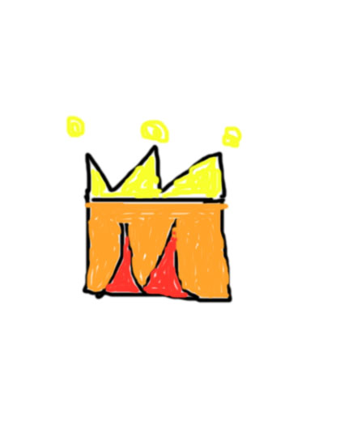

Date: 5/27/2016

Author: Sherry Ma

Teacher: Miss Morin

School: Académie Ste Cécile International School

Content page:

Section A: Project proposal

Section B: Reflection

Section C: Design

Section D: Statement and analysis of the problem

Section E: Implementation (see code)